Friday, March 13, 2020

Re: Coming to Work if you have been exposed to or think you may have COVID-19

Dear employee(s):

What to do if you have confirmed or suspected COVID-19
- Do not go to work, school or public areas.
- Restrict activities outside your home, except for getting medical care.
- Separate yourself from other people and animals in your home.
- Monitor your symptoms and call before visiting your doctor. If you have an appointment, be sure you tell them you have or may have COVID-19.
- If you are having a medical emergency, call 9-1-1. Notify dispatch that you have or may have COVID-19
- Remain in home isolation for 7 days OR until 72 hours after your fever has resolved (and symptoms get better) whichever is longer.

If you may have had close contact with a person with COVID-19 but are not sick
  - Monitor your health for fever, cough and shortness of breath for 14 days after your last contact with the ill person.
  - Do not go to school or work. Avoid public places for 14 days.

What to do if you have COVID-19 symptoms but haven't been around anyone who has been diagnosed with COVID-19
- The most common symptoms of COVID-19 are fever, cough, and shortness of breath. These can be symptoms of other respiratory illnesses as well as COVID-19.
- If you are in a high-risk category, and have symptoms of COVID-19, call your healthcare provider for advice. If you are at risk for serious illness, your healthcare provider may arrange a test for COVID-19.
- If you do not have a high-risk condition and your symptoms are mild, you do not need to be tested for COVID-19. Do not go out when you are sick, practice excellent hygiene, and wear a facemask when you are around other people if you can.
- Cover coughs and sneezes. Avoid sharing personal household items. Clean your hands often. Clean all "high-touch" surfaces like doorknobs often.
- Monitor your symptoms and call your health care provider if symptoms worsen.
- Stay home and avoid others for 72 hours after your fever goes down and symptoms get better.

Sincerely,
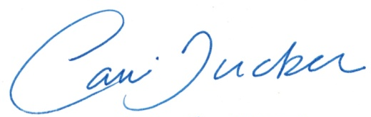

Carri Coleman Tucker
Sr. EHS Specialist
O’Brien Safety Services

